**Home Screen Power BI:**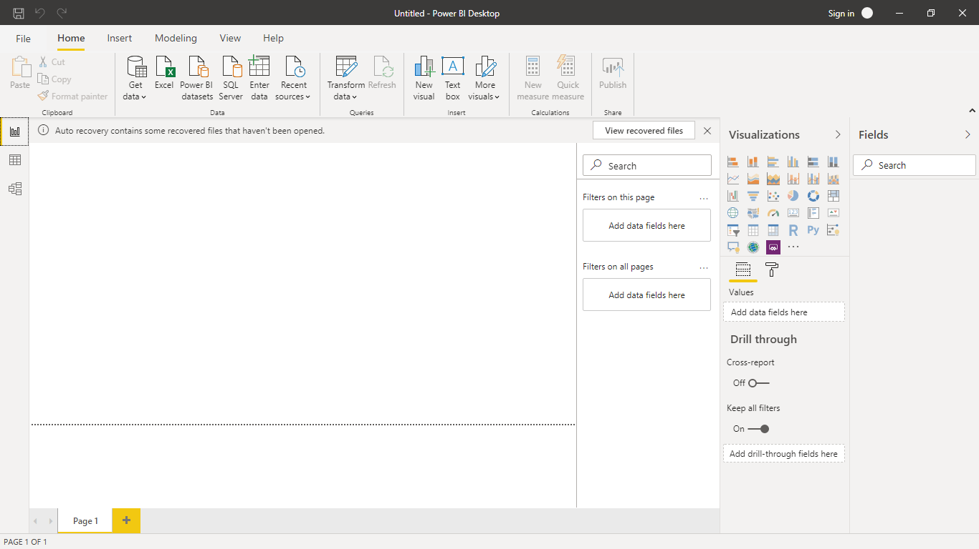

**Data View:**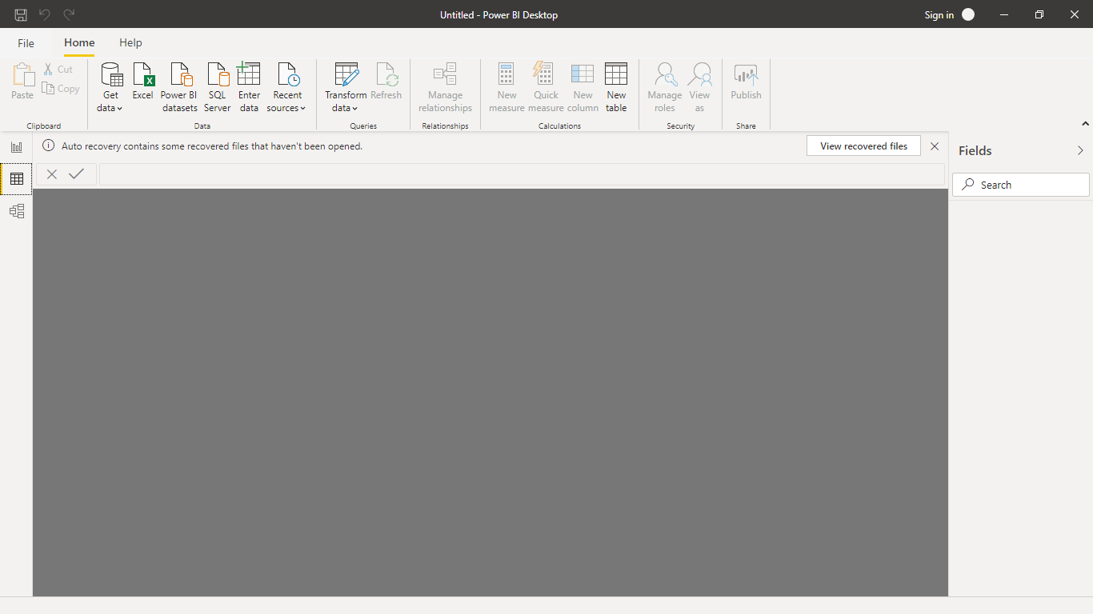

**Model View:**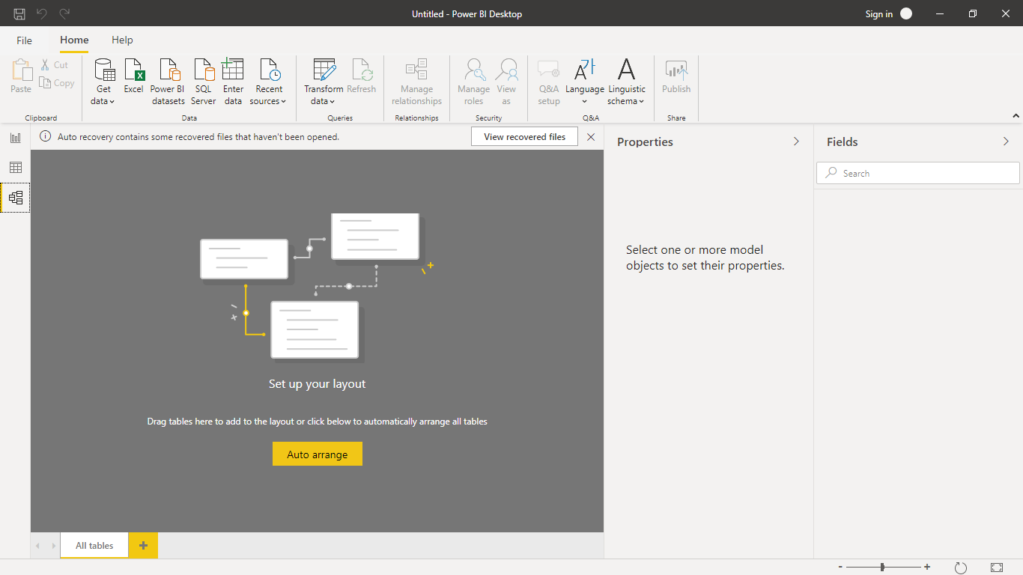

**Power Query Editor:**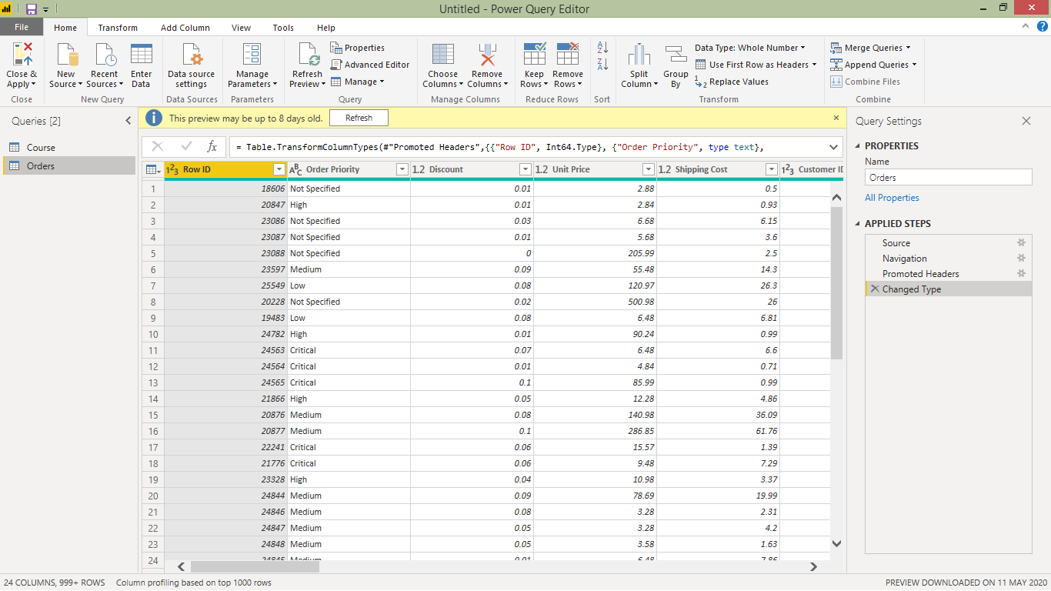

**Advance editor:**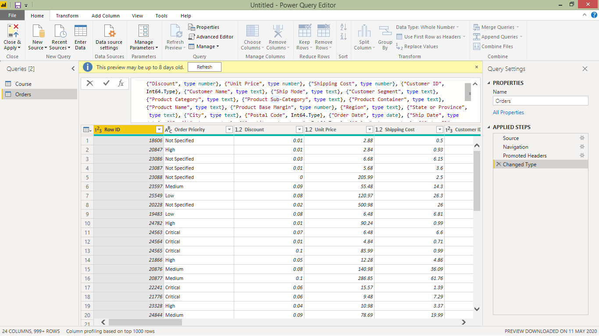

**Power BI Desktop**: Free for individual use.

**Power BI Pro:** RS660.00/- per User per month

**Power BI Premium:**Rs3,30,190.00/-